CHAPTER 1

INTRODUCTION

**1.1 Subtitle 1**

Font style for entire report must be times new roman. Chapter number and title must be capitalized with font size of 16pt bold. Subtitle 1 is 16pt with each word capitalized with bold. Subsection under a subtitle is 12pt with bold, each letter capitalized. All the content of the document is 12pt size with 1.5 Spacing. Left margin 1 inch and right margin 0.5 inch. Use justify option for both left and right alignment. A paragraph may contain maximum of 12 lines and an empty space to be left between each paragraph.

All figures must be numbered with corresponding chapter number like Fig 1.1, Fig 1.2 etc for chapter 1 and Fig 2.1, Fig 2.2 etc for chapter 2 and so on.. with figures in center alignment and the caption to be mentioned below the figure.

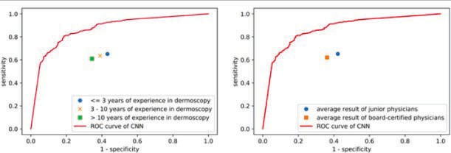

**Fig 3.1: ROC curve CNN and dermatologists**

All tables must be numbered with corresponding chapter number like Table 1.1, Table 1.2 etc for chapter 1 and Table 2.1, Table 2.2 etc for chapter 2 and so on.. with tables in center alignment and the caption to be mentioned above the Table.

Every chapter must start in new page. Page numbers are started from chapter 1 and to be included till the end of the report. Page numbers can be given at the bottom of the page with center alignment.

1

All references must be cited inside the text with sequential numbers[1] and to be listed in the same order in references. Two articles can be cited as [4,5] and multiple references can be cited as [7-10]. Minimum 15 references to be included.

Proofs must be included for all publications and plagiarism report to be generated using turnitin with the help of your guide with similarity index less than or equal to 10 percent. Total number of pages in the report is minimum 30 excluding coding and screenshots.